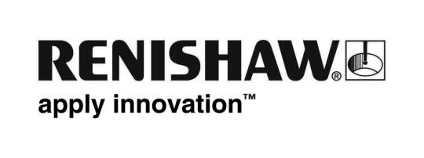
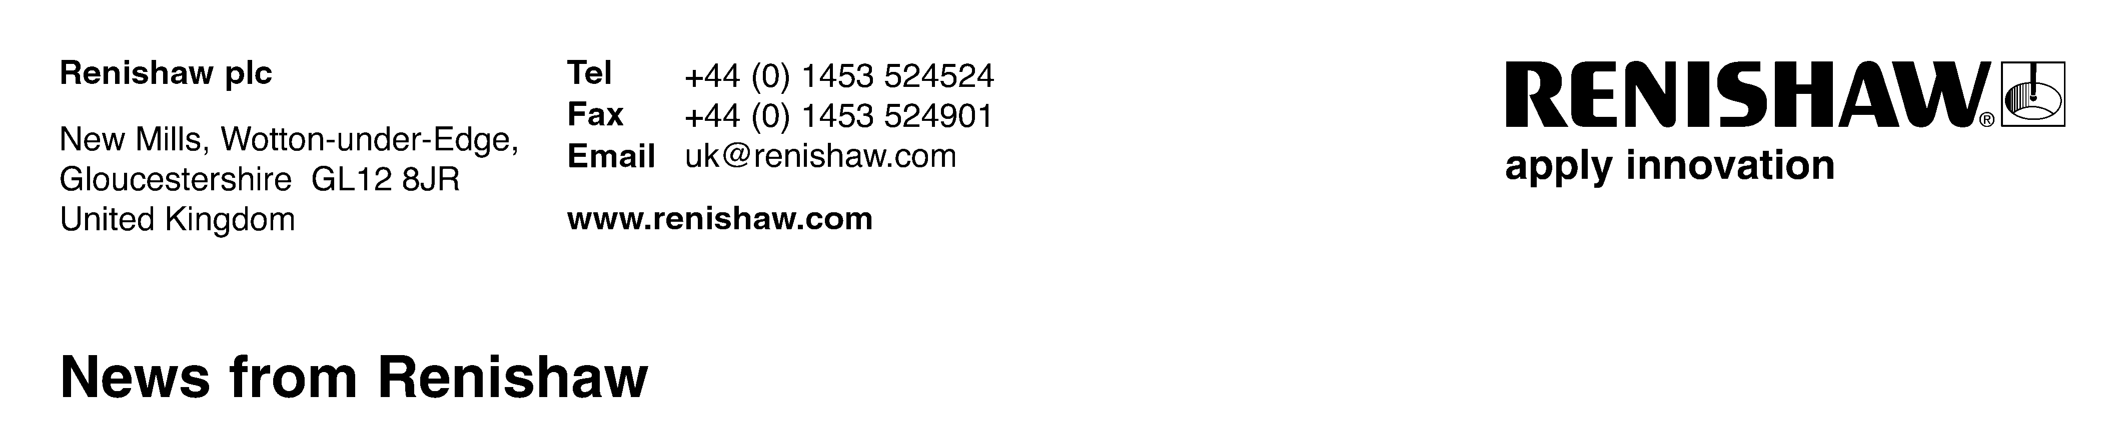
April 15th 2011 – for immediate release Further information: Chris Pockett, +44 1453 524133

Renishaw acquires MTT Investments Limited

Renishaw plc, the global engineering technologies company, has acquired the entire share capital of MTT Investments Limited and its subsidiary, MTT Technologies Limited (MTT). Based in Stone, Staffordshire, UK, MTT designs, develops and manufactures additive manufacturing and rapid prototyping systems, including laser melting, metal casting, and vacuum casting machines and processes.

Speaking about the agreement which was signed on 8th April, Sir David McMurtry, Renishaw’s Chairman and Chief Executive, says, “MTT has a range of interesting technologies including laser melting equipment which currently has its main markets in aerospace and medical devices, but also has potential for use in other sectors. All its products are complementary to Renishaw’s existing technologies and business and we look forward to developing an exciting new business together.”

MTT Technologies Limited has 35 employees, with subsidiaries in the US and Italy, and a branch office in France. Its operations will be incorporated within Renishaw as a new product division and will continue to be based in Staffordshire.

According to MTT’s CEO, Simon Scott, the business fit between the two companies is perfect. “We’re confident that Renishaw will be able to provide us with the ability to fully unlock the potential of laser melting allowing us to compete with our peers and aim for a market leadership position. It has recognised the potential of the technology through the achievements we have made so far on very limited resources. Renishaw also uses additive manufacturing for its own commercial activities and therefore I believe that Renishaw has a good level of confidence in both the technology and the potential of our team.”
Ends

