May 2012 – for immediate release Further information: Chris Pockett, +44 1453 524133

First Peruvian surgical procedure for Renishaw’s NeuroMate® robot
Renishaw is pleased to announce that the first neurosurgical robotic procedure with its NeuroMate® stereotactic system has taken place at the Neurosurgery Department of Hospital Nacional Guillermo Almenara in Lima, Peru. This is the first South American installation of NeuroMate, which provides cutting-edge robotic technology that enables neurosurgeons to deliver field proven neuro-implantable devices with pinpoint accuracy.

Dr. Luis Bromley, Chief of the Neurovascular and Tumour Surgical Department at the Neurosurgery Department said, “The NeuroMate surgical robot provides our department a platform solution for planning and executing a broad range of stereotactic neurosurgical procedures. We expect to enhance the safety and cost-effectiveness of these interventions, while improving patient outcomes through the accuracy and reliability of the system.”

“The NeuroMate integrated very nicely in our surgical workflow and the benefits of having a robotic assistant in the OR were evident in our first experience”, added Dr. Camilo Contreras Campana, who performed the first NeuroMate procedure in the hospital.

Dr. Abed Hammoud, CEO of Renishaw Mayfield SA said, “This installation confirms once again the trust of functional neurosurgeons worldwide in the proven performance of the NeuroMate robot. Our training and clinical support teams worked closely with Dr Bromley, Dr Contreras Campana, and the hospital staff to ensure the seamless integration of the NeuroMate into their procedure workflow, thus aiding surgeons to provide positive outcomes for their patients.”
- ENDS -

Notes to editors
Renishaw is a global company with core skills in measurement, motion control, spectroscopy, neurosurgical products and precision machining. The company has over 2,700 employees based at offices in 32 countries, and is listed on the London Stock Exchange (LSE:RSW) where it is a constituent of the FTSE 250.

For more information visit www.renishaw.com
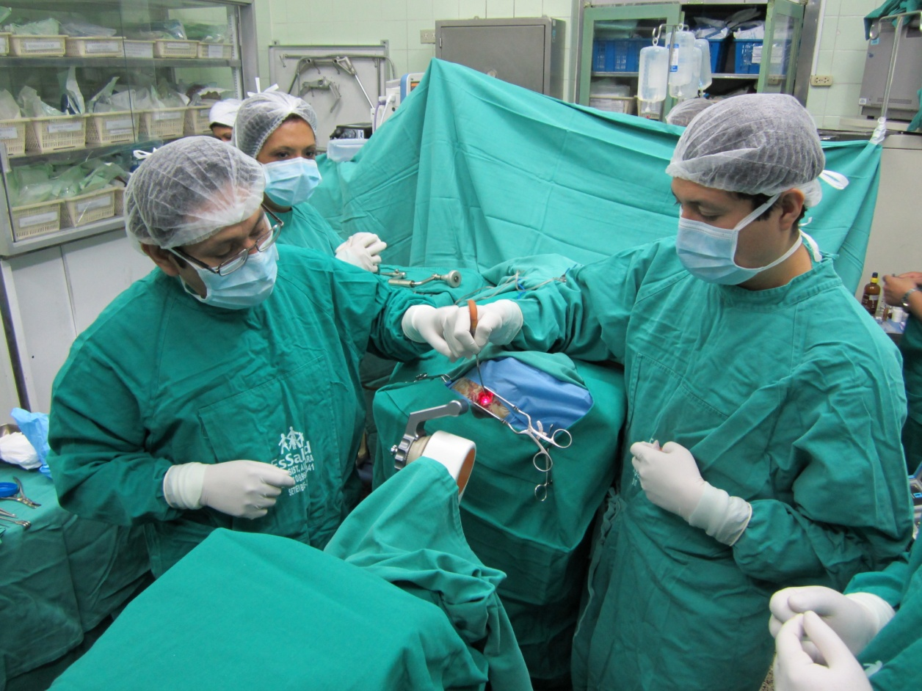

First procedure with the NeuroMate® stereotactic system taking place at the Neurosurgery Department of Hospital Nacional Guillermo Almenara in Lima, Peru
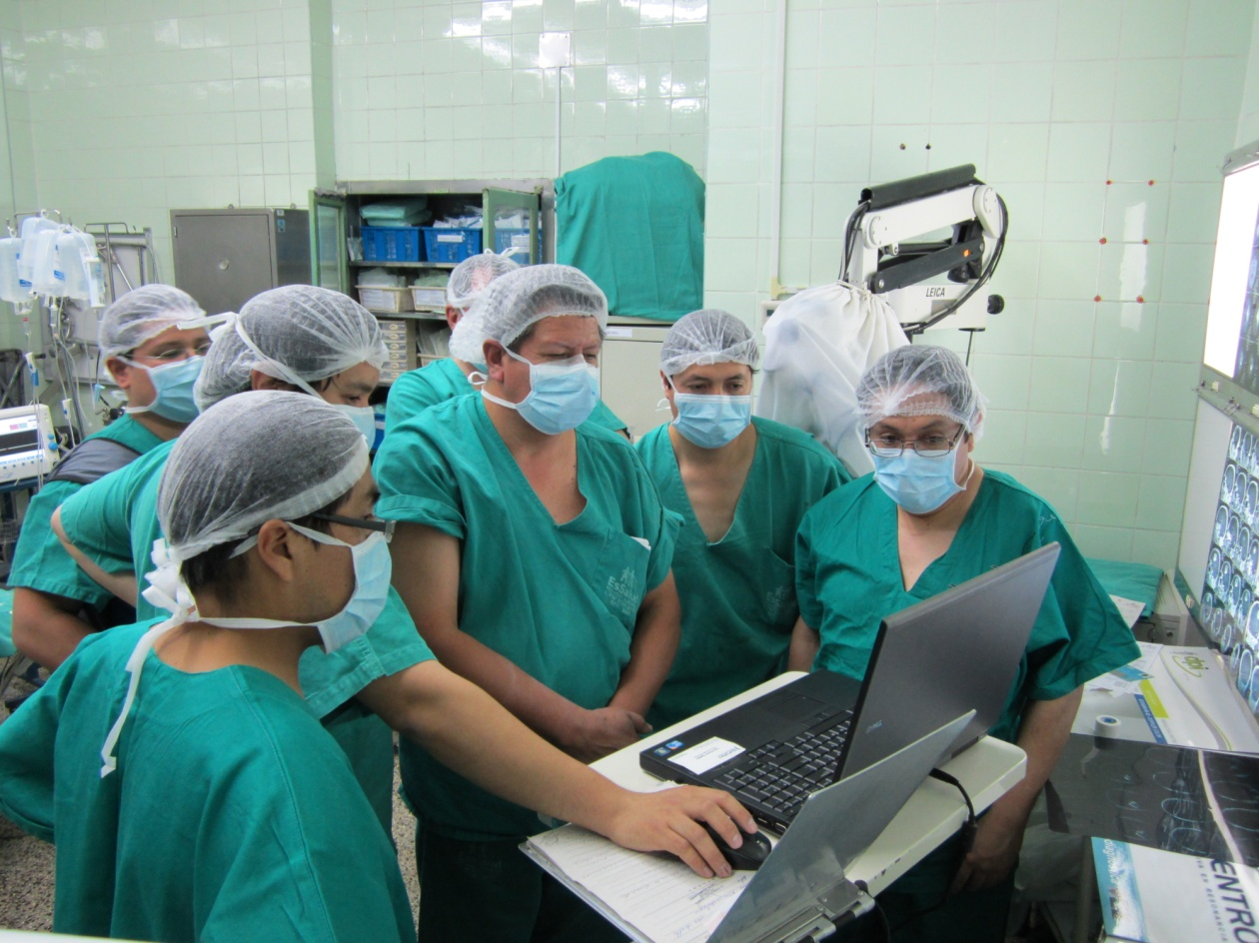

Dr Camilio Contreras Campana (centre) led the first NeuroMate procedure at the Hospital Nacional Guillermo Almenara in Lima, Peru

