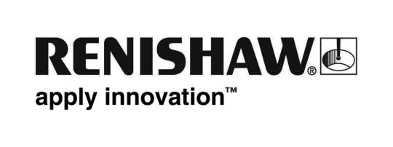
July 2016 Enquiries: Chris Pockett, Head of Communications (+44 1453 524133)

Renishaw supports Land Rover BAR at Portsmouth America’s Cup event

Renishaw will be showing its ongoing support for Land Rover BAR, the British Challenger for the 35th America’s Cup at the Louis Vuitton America’s Cup World Series in Portsmouth between July 22-24th. As an official supplier to Land Rover BAR and a Technical Innovation Group Member, Renishaw will be a guest exhibitor in the Tech Zone within the Race Village. The company will display its technical and product expertise in the fields of additive manufacturing and position feedback encoding.

Renishaw will exhibit a series of additively manufactured parts including a manifold designed especially for the Land Rover BAR team and produced on a Renishaw additive manufacturing machine. Also available to see on the stand will be a pair of additively manufactured nose cones used in the BLOODHOUND Supersonic Car, which will attempt to break the land speed record in autumn 2017.

“Renishaw has been working closely with the Land Rover BAR Technical Innovation Group to bring the oldest international sporting trophy in the world to Britain for the first time since 1851,” explained Chris Pockett, Head of Communications of Renishaw. “It is a real delight to see the best in British design, technology and innovation working together to bring the cup home.”

The Land Rover BAR Team Principal and skipper is Ben Ainslie, who has won four Olympic gold medals for sailing. The Land Rover BAR team currently sits in second place behind the Emirates team New Zealand and hopes to defend its previous Portsmouth win in the first event of the series.

The Portsmouth event is set over an exciting three days, with spectacular racing, air displays from the Red Arrows and a wide range of other entertaining activities for spectators.

The Louis Vuitton America’s Cup Series is part of the sailing programme for the 35th America’s Cup that ends in Bermuda in 2017. The competition features world-class sailors on AC45f catamarans. The six teams competing are Artemis Racing, Landrover BAR, Emirates Team New Zealand, Oracle Team USA, Groupama Team France and SoftBank Team Japan.

Further information on Renishaw’s support for Land Rover BAR can be found here.

Ends 349 words
Notes to editors
UK-based Renishaw is a world leading engineering technologies company, supplying products used for applications as diverse as jet engine and wind turbine manufacture, through to dentistry and brain surgery. It has over 4,000 employees located in the 33 countries where it has wholly owned subsidiary operations.

For the year ended June 2015 Renishaw recorded sales of £494.7 million of which 95% was due to exports. The company’s largest markets are China, the USA, South Korea, Germany and Japan.

Throughout its history Renishaw has made a significant commitment to research and development, with historically between 14 and 18% of annual sales invested in R&D and engineering. The majority of this R&D and manufacturing of the company’s products is carried out in the UK.

The Company’s success has been recognised with numerous international awards, including eighteen Queen’s Awards recognising achievements in technology, export and innovation.

Renishaw is listed on the London Stock Exchange (LSE:RSW) where it is a constituent of the FTSE 250, with a current valuation of around £1.5 billion.

Further information at www.renishaw.com

