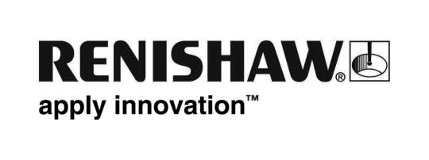
February 2013 – for immediate release
Enquiries: Chris Pockett, Head of Communications (+44 1453 524133)

Renishaw expands in central China with new Wuhan Liaison Office

Renishaw, the global engineering technologies company, has opened its eleventh office in China with a new liaison office in Wuhan. The new office is located within a state-level high-technology industrial development zone in the south east of Wuhan, which is the capital city of Hubei province.

The establishment of the office in Wuhan highlights the important strategic position of China’s central region for Renishaw. Paul Gallagher, Managing Director of Renishaw (Shanghai) Trading Co Ltd said, “Our goal is to offer enhanced commercial and technical support to customers throughout China’s rapidly growing manufacturing industries. The setup of the Wuhan liaison office gives us the opportunity to offer our customers in the central region better service and support as well as show them how Renishaw products can help them improve their quality and their productivity.”

As a world leader in metrology and process control, Renishaw is committed to maintaining stability and sustainable growth with its customers. The establishment of the liaison office in Wuhan is another expansion in central China following the opening of liaison offices in Chengdu and Chongqing in 2012.

The Wuhan office is located within a development zone that is focused on high-tech enterprises for modern equipment manufacturing, such as infrastructure, energy, aviation, and industrial measurement. It is the 11th Chinese office to be setup by Renishaw which opened its first office in Beijing in 2004. Renishaw now employs over 100 staff in China.
Ends

About Renishaw
Renishaw is a world leading engineering technologies company, supplying products used for applications as diverse as jet engine and wind turbine manufacture, through to dentistry and brain surgery. It employs over 3,000 people globally, some 2,000 of which are located at its 14 sites in the UK, plus over 1,000 staff located in the 32 countries where it has wholly owned subsidiary operations.
More information about Renishaw and its products can be found at www.renishaw.com.

