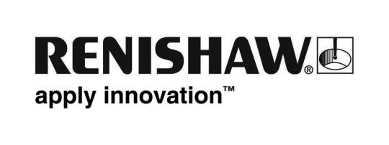
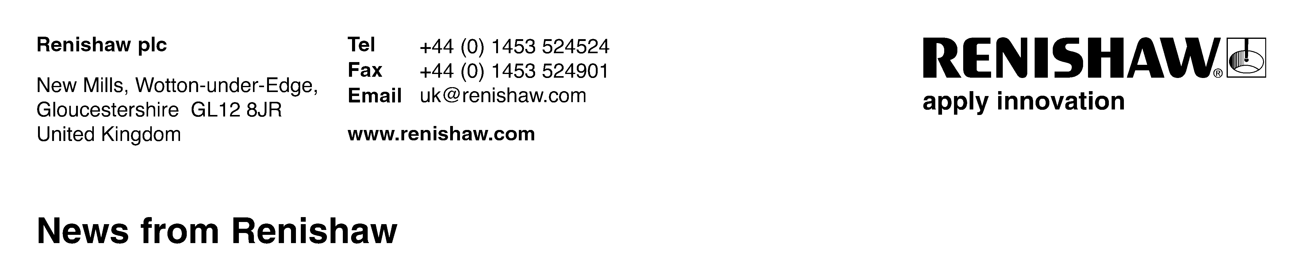
Enquiries: Robin Weston, Marketing Manager, Additive Manufacturing Products Division (017785 815651)
The new name in additive manufacturing
Renishaw’s laser melting is a pioneering additive manufacturing process capable of producing fully dense metal parts direct from 3D CAD using a high-powered fibre laser. Parts are built from a range of fine metal powders that are fully melted in a tightly controlled atmosphere layer by layer in thicknesses ranging from 20 to 100 microns.
The current range of machines are the third generation designs and, following several years of detailed market feedback from key development partners and clients, now represent state-of-the-art manufacturing systems. Key features, providing significant enhancements over previous models, include variable powder delivery, ultra low oxygen content in the build atmosphere and an unparalleled safe change filter system to minimise user materials contact.
The range comprises the AM250 and the AM125, both of which feature vacuum technology and low gas consumption. The machine has been designed for ease of use within a manufacturing environment and features a touch-screen interface and various menu options for machine preparation and clean down. Machine robustness has been given high priority, adopting a ‘machine tool’ approach to use and serviceability. Consumables costs are minimised through careful design and features, such as the soft re-coater blade that can be rotated several times before replacement and the use of low-cost filter elements, right through to low gas consumption — all contribute to system reliability and low cost of ownership.
Renishaw’s laser melting systems have always processed a wide selection of materials and the new range is no exception, but with the additional benefits of rapid materials changeover on the AM125 via a cassette type materials delivery system and by the removable hopper on the AM250; particularly useful where materials development or a range of materials are in use. The capability to safely process reactive materials, such as titanium and aluminium, is a standard feature on Renishaw AM machines. In particular, the gas knife that clears away reactive sooty emissions and the heated build plate are both pre-requisites for the successful processing of both materials.
Both the new machines feature a fully welded vacuum chamber, enabling low-pressure evacuation followed by a recharge with high purity argon gas. The gas consumption rate, after the initial chamber flood, is extremely low, and allows operation at oxygen concentrations below 50 parts per million — a crucial factor when processing reactive materials such as titanium and aluminium; and contributing significantly to material integrity and mechanical performance.
All file preparation is completed off-line through a choice of interface, either Marcam Autofab software or via Materialise Magics. Once complete, the build file is uploaded to the machine via a secure network or direct connection. Product traceability has been improved by the addition of process data and event logging as standard, with various additional process control options on request.
More technical information about laser melting systems is available from the Renishaw team on +44 1785 815651 or via email at additive@renishaw.com

Ends

