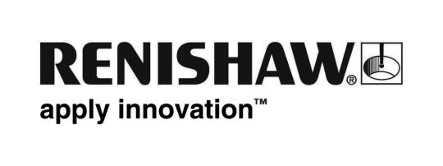
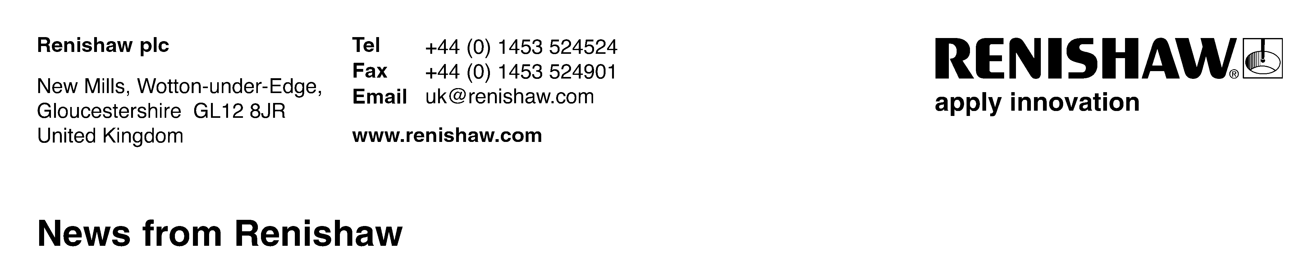
3rd February 2011 – for immediate release Enquiries: Chris Pockett (+44 1453 524133)

TV star visits leading engineering business
Gloucestershire’s largest business employer, Renishaw plc, played host this week to John Barrowman, the popular media celebrity, and star of well-known TV programmes such as Torchwood, Tonight’s the Night and Doctor Who.

Monday’s visit to Renishaw’s New Mills headquarters, near Wotton-under-Edge, formed part of Mr Barrowman’s research into a potential TV documentary for his production company Barrowman Barker Productions about new medical procedures to treat degenerative diseases, such as Parkinsons.

The visit also included an overview of Renishaw’s advanced engineering technologies and the way that these are being applied to new applications within the world of neurosurgery. He was accompanied by his brother-in-law Professor Steven Gill, who is a world-leading neurosurgeon based at Frenchay hospital, Bristol, where the first of Renishaw’s new enhanced surgical robots has recently been installed.

Speaking about Mr Barrowman’s visit, Stuart Campbell, Senior Sales & Marketing Engineer for Renishaw’s Neurological Products Division, said, “John seemed very interested in how our measurement technologies, used in the manufacture of critical parts within sectors such as aerospace and automotive, are now being used to help neurosurgeons perform demanding surgical procedures. This was particularly so because his father is a former engineer.”

Ends

Caption: John Barrowman with a Renishaw neuromate surgical robot

